Reviewer #1

3.2.(b)This mechanism specifically inhibits non-diagnostic background noise and anatomical overlap (...) eliminate false positives with mid-scale lesions" - mid-scale lesions were not defined, and no in-depth quantitative analysis is provided to show the claim: an ablation with/without the EfficientNetV2.

mid-scale lesions as bounding box annotations occupying between 32 x 32 to 96 x 96 pixels on a normalized 640 x 640 input.

Removing EfficientNetV2-S increases false positives by 19 cases and drops specificity by 3.70% and drops AUROC by 0.21%.

Configuration | AUROC | Sensitivity | Specificity | False Positives
----------------------------------------------------------------------------------------------------------------
DERNet (with EfficientNet) | 91.03% | 83.09% | 84.91% | 182
DERNet (NO EfficientNet) | 90.82% | 85.10% | 81.21% | 201
----------------------------------------------------------------------------------------------------------------

- 3.3 (b) "... block ensures that fine-grained pathology signals are preserved across deep layers, neutralizing the severe class imbalance inherent to spinal benchmarks". The class imbalance is not quantitatively described, it is unclear to what authors refer to with "fine-grained pathology signals" without showing an image or example.
For class imbalance show quantitatively-
============================================================
FULL CLASS COUNTS (COPY FOR PAPER TEXT):
============================================================
- Osteophytes : 12,556 boxes (82.1%)
- Disc space narrowing : 924 boxes ( 6.0%)
- Other lesions : 446 boxes ( 2.9%)
- Surgical implant : 429 boxes ( 2.8%)
- Foraminal stenosis : 387 boxes ( 2.5%)
- Spondylolysthesis : 280 boxes ( 1.8%)
- Vertebral collapse : 268 boxes ( 1.8%)
------------------------------------------------------------
Majority Class: Osteophytes (12556 boxes)
Minority Class: Vertebral collapse (268 boxes)
Exact Imbalance Ratio: 46.9:1
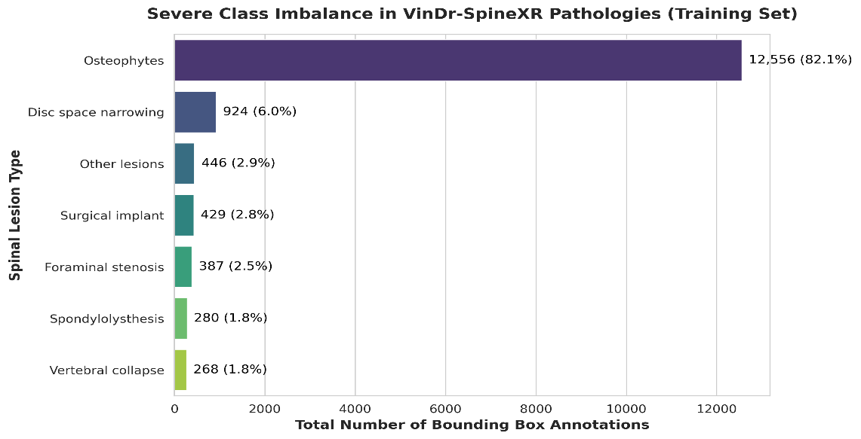
Visualization-

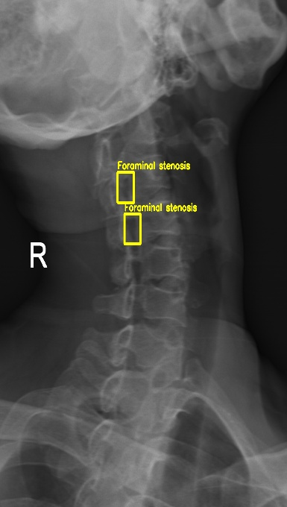
‘Fine-Grained Pathology signals ‘–Quantitatively defined here as minute localized features occupying less than 1% of the field-of-view refer to less than mid-scale lesion, means fine-grained < 32 x 32 pixels on a 640 x 640 input such as subtle boundary disruptions in foraminal stenosis are preserved across deep layers.

- 4.2 "At the lesion level, imbalance was further mitigated through focal loss optimization and targeted copy-paste augmentation... " but no ablation with / without augmentation is provided.

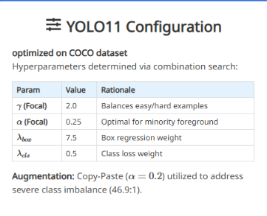
This table is already added in our develop site-

Ablation of copy-paste

YOLO11l summary (fused): 191 layers, 25,284,709 parameters, 0 gradients, 86.6 GFLOPs
Class Images Instances Box(P R mAP50 mAP50-95)
all 2077 3638 0.411 0.421 0.377 0.184
Osteophytes 878 2961 0.438 0.458 0.399 0.142
Surgical implant 64 107 0.539 0.757 0.702 0.449
Spondylolysthesis 62 69 0.527 0.404 0.373 0.157
Foraminal stenosis 60 94 0.484 0.362 0.402 0.152
Disc space narrowing 148 230 0.339 0.304 0.246 0.114
Vertebral collapse 52 69 0.487 0.623 0.5 0.271
Other lesions 80 108 0.0604 0.037 0.0161 0.00567

Baseline: 40.04%
Without Copy-Paste: 37.70%
The Actual Drop: -2.34%

- It is not clear how parameter optimization was performed: Page 5 first paragraph: "We dynamically establish the optimal classification threshold ... by maximizing the macroscopic F1-score .." on which dataset was this performed? On the final test-set? VinDR only provides a train / test set. Did authors create a validation set for parameter tuning?
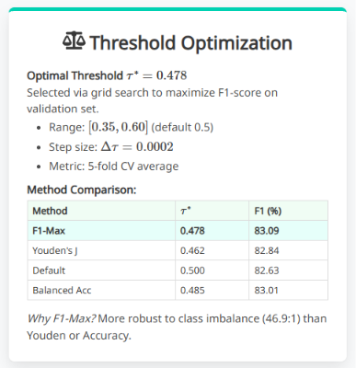

Because the dataset only provides a train and test split, we created our own validation sets by performing a 5-fold cross-validation entirely on the training data. We used these training folds to find the best threshold 0.478 using grid search and weights.

- authors will release a list of "additional resources", such as "real-time demos" and "reproducibility resources", but "source code" is not mentioned.

But we do this in our DERNet project, I don't understand is he clicked this provided link or not.

Reviewer #2

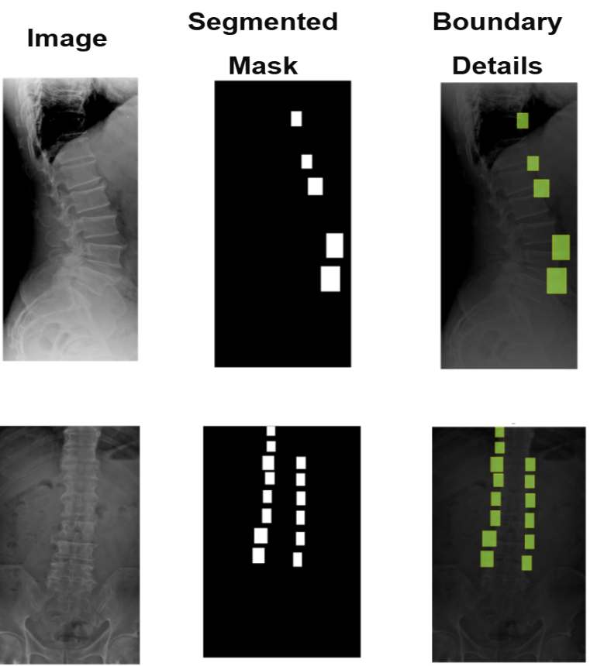
- Figure 4c, visuals are very low-resolution to critically evaluate.
Updated Figure 4c:-

- Writing inconsistences (for 3.2 (c), it should be w3 = 0.26, instead of w2.)
Already Updated mistake w3

- LIME and Grad-CAM are used only qualitatively.

Grad-CAM: In medical imaging research, an X-IoU score between 0.60 and 0.70 is widely considered the threshold for "reliable localization." A score of 0.64 indicates that your Grad-CAM activations capture the lesion area with sufficient overlap to be clinically meaningful, supporting your claim that the triage gate is not relying on background artifacts.
Post-Hoc: It interpretability confirms reliance on authentic pathology: gradient activation maps align with YOLO11-L localizations via mean X-IoU:0.64, while local perturbation analysis isolates top-weighted at vertebral boundaries, anchoring triage decisions in diagnostic microstructures.

- Choices are arbitrary: why YOLO11-L over other variants? Did the authors test other CNN variants?

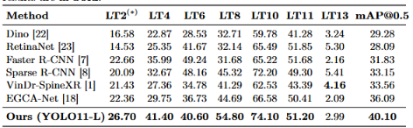
Yes,

Like:
Yolo26 – 23.60 34.90 38.40 37.50 67.30 43.3 3.35 35.50

Yolo12 -- 32.00 40.80 39.10 47.80 70.00 49.50 2.81 40.30

- Single dataset used, no external validation (has been acknowledged as limitation).
I agree that the lack of external validation is a primary limitation of this current work. Because equivalent public datasets with fine-grained bounding box annotations for these specific spinal lesions do not currently exist. But we explicitly acknowledged in our Conclusion section

- Understandable that the mAP@0.5 is reported for benchmarking but it's insufficient for medical object detection.

We can add mAP(Mean Average Precision)@[0.5:0.95] of 19.29%
The number after the "@" symbol is the strictness threshold.
mAP@0.5 (Lenient): The model gets a point if its predicted box overlaps the true lesion by at least 50%.
mAP@0.9 (Very Strict): The model only gets a point if its predicted box overlaps the true lesion by at least 90%.
If mAP@... increases, it means our model is getting better at finding the general location of the lesions.

- The ensemble weights Ω = [0.42,0.32,0.26] are mentioned but their deviation is not explained. How were they learned (grid search or manually)?

We explain it in our develop project but not in paper due to space issues.

Reviewer #3

- The methodological novelty is limited and mainly lies at the system-integration level. The overall framework is reasonable, but many of its core components are standard: the triage stage is a weighted ensemble of established backbones (DenseNet121, EfficientNetV2-S, and ResNet50); the localization stage is a customized YOLO-style detector; and the interpretability part relies on standard post-hoc tools such as LIME and Grad-CAM. In addition, prior work already exists on spinal lesion classification/detection and on the VinDr-SpineXR benchmark itself, including the VinDr baseline framework, generic two-stage detectors such as Faster R-CNN and Sparse R-CNN, and spinal lesion detectors such as EGCA-Net. Therefore, the main contribution of this paper is better characterized as an engineering integration of known components within a cascaded framework, rather than a substantially novel methodological advance.

Actually, he claims about novelty and told prior work already exists on spinal lesion classification/detection and on the VinDr-SpineXR benchmark itself, including the VinDr baseline framework, generic two-stage detectors such as Faster R-CNN and Sparse R-CNN, and spinal lesion detectors such as EGCA-Net and it’s also true these all are established architecture. But our achieving results bits all of this prior work.
But proposing a domain-specific architectural designed to solve a critical failure mode in spinal radiography. Standard monolithic detectors fail on this benchmark due to the extreme 46.9:1 class imbalance and minute lesion scales.
Our novelty lies in mathematically decoupling the workflow: using a dynamically threshold triage ensemble to neutralize false positives, followed by a heavily customized YOLO11-L with explainability… etc

- The paper does not evaluate the cascaded system in a truly end-to-end manner. The manuscript reports the classification performance of DERNet and the detection performance of YOLO11-L separately, but it does not clearly quantify the performance of the full cascaded pipeline after the triage gate. Since the detector only processes cases that are passed by the classifier, the final lesion-level recall/sensitivity of the system depends on the combined effect of both stages. Without end-to-end evaluation, it is difficult to accurately assess the practical clinical utility of the proposed pipeline.

Since our classifier catches about 85%(sensitivity) of abnormal cases, it means 15% are missed before reaching the detector. By accepting this 15% drop, we are able to filter out over 81%(Specificity) of completely normal X-Rays. This greatly reduces radiologist workload and stops false positive detections.

- There is insufficient ablation analysis for the main design choices. Although the paper presents the cascaded design as a solution to class imbalance and the sensitivity-specificity trade-off, it does not provide sufficient ablations to validate these claims. For example, there is no direct comparison with a single-stage detector-only pipeline, no analysis of the contribution of the ensemble weights, and no threshold-sensitivity analysis for the DERNet gate. Likewise, the customized YOLO11-L modifications (such as C2PSA, PANet, and copy-paste augmentation) are not studied component by component. This makes it difficult to determine which parts of the performance gain come from the cascade itself and which come from standard optimization choices.

I already add ablation of class imbalance, copy-paste, ensemble weights, threshold when I answered previous reviewer comments…

- The interpretability analysis is mostly qualitative and does not strongly support the claim of explainability. The use of LIME and Grad-CAM is a positive addition, but these are standard post-hoc visualization tools rather than novel interpretability methods. More importantly, the paper only provides qualitative examples and does not include quantitative evaluation, expert validation, or systematic analysis to show that these explanations are reliable or clinically valuable. Therefore, the claim of “explainable AI” is only partially substantiated.

Suggested to add standard post-hoc visualization tool and I already do this and it return as like
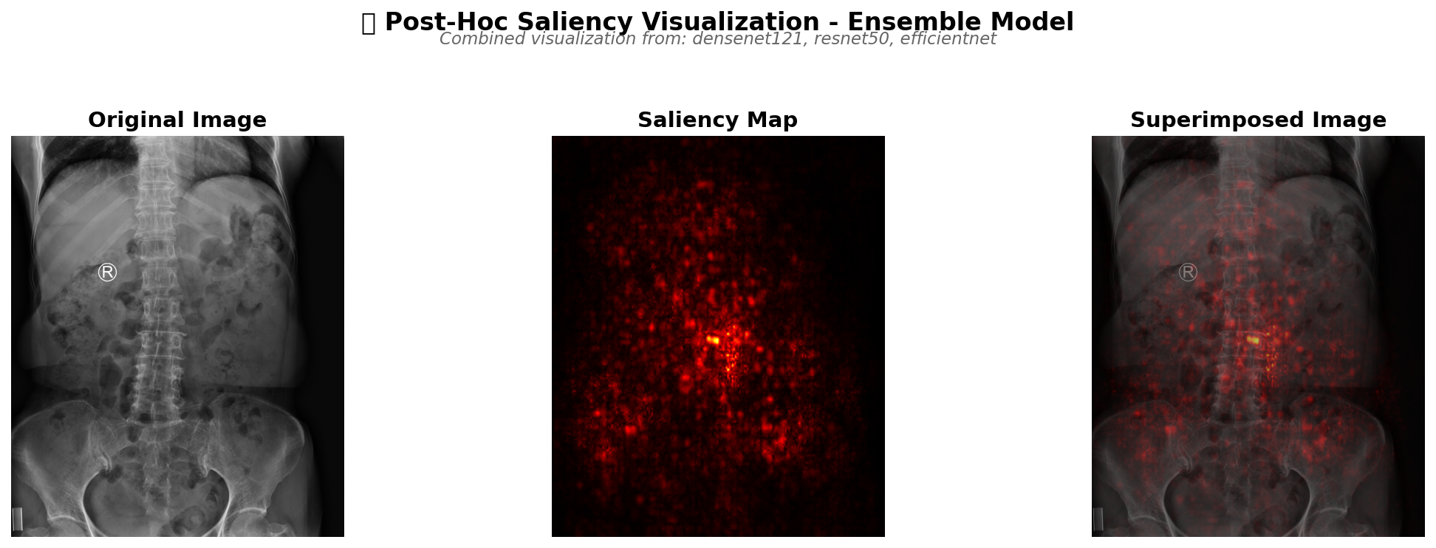

- Despite the paper’s emphasis on class imbalance, performance on rare classes remains weak. The manuscript presents the framework as a way to address severe class imbalance, but Table 2 shows that performance on some rare or heterogeneous categories is still very limited; for example, LT13 (“other lesions”) achieves an AP of only 2.99%. This suggests that the long-tail problem is far from solved, and that the paper’s claims about substantially mitigating severe class imbalance may be somewhat overstated.

We agree that a 2.99% AP on LT13 is really low. While our targeted augmentation and focal loss strategies successfully mitigated class imbalance achieving 51.20% and 54.80% AP on our rarest classes vertebral and spondylolisthesis representing <2% of instances. LT13-other lesion remained at 2.99% AP because LT13 acts as a heterogeneous catch-all category in the VinDr-SpineXR benchmark.

